Low Level Design (GET EMPLOYEE BY ID module)

|  |  |
| --- | --- |
| **Project Code** | GROUP-1 |
| **Project Name** | Expense Management System |

|  |  |  |
| --- | --- | --- |
| **Prepared/Modified by** | **Role** | **Date of Preparation** |
| H.MIDHUN KUMAR/NEVIL JEEVAN | Software Engineer/ANALYST | 29/08/2018 |
| **Reviewed by** | **Role** | **Date of Review** |
|  | Software Engineer | 29/08/2018 |
| **Approved by** | **Role** | **Date of Approval** |
|  | Training Manager |  |
| **Circulation List** | [nevil.nevil@capgemini.com](mailto:nevil.nevil@capgemini.com)  [midhun.kumar-h@capgemini.com](mailto:midhun.kumar-h@capgemini.com)  [thotta.balaji.kumar@capgemini.com](mailto:thotta.balaji.kumar@capgemini.com)  [aishwarya.mankar@capgemini.com](mailto:aishwarya.mankar@capgemini.com)  [tripti.verma@capgemini.com](mailto:tripti.verma@capgemini.com)  [veena.kamat@capgemini.com](mailto:veena.kamat@capgemini.com)  [faizahmed.mullani@capgemini.com](mailto:faizahmed.mullani@capgemini.com)  [minaj.shaikh@capgemini.com](mailto:minaj.shaikh@capgemini.com)  [pragathi.pragathi@capgemini.com](mailto:pragathi.pragathi@capgemini.com) | **Version Number of the template:1.0** |
| **Version Number** | 1.3 |  |

Table of Contents

1. Description Of The Unit 3

2. References 4

3. Dependencies / Assumptions 5

4. Class Diagrams 6

5. Sequence Diagrams 7

6. Design Components 8

6.1 List Of UI Components 8

6.2 List Of Design Classes 8

7. Re-Usable Routines/Components 9

8. Messages 10

9. Configuration Files 11

10. Crud Matrix Table 12

11. Data Mapping Matrix 13

12. Action Flow Matrix 14

13. Stored Procedures 15

14. Program Specification / Pseudo Code 16

REVISION HISTORY OF THE WORK PRODUCT 17

# Description Of The Unit

The GET by ID employee module allows the admin of the application to show the details of the employee by ID that is saved in the database. This module can be used only by the admin of the application.

The generation of the employee details is done using the Postman and when we view the details in JSP page, the details of the employee will be shown. The get functionality shows all the details of the employee like employee name, employee designation, employee domain, employee salary, employee emailid, employee gender, and employee password. If the entered employee ID are invalid, appropriate error messages are displayed.

After showing all the employee details based on the ID, the details are also shown from MySQL database using the desired query..

# References

| **Reference** | **Description** |
| --- | --- |
| Class Diagram | PLP\PLP Documents\ProjectDocuments\DesignDocuments\HLD\Class Diagram |
| URS | PLP\PLP Documents\ProjectDocuments\Requirements |
| UTP | PLP\PLP Documents\Testing\UTP |
| DB Design | PLP\PLP Documents\ProjectDocuments\DesignDocuments\HLD\DB Design |

# Dependencies / Assumptions

**Dependencies:**

The employee should be logged in.

**Assumptions:**

The employee details are generated in the MySQL database based on the ID.

# Class Diagrams

[Class Diagram](../../HLD/Class%20Diagrams)

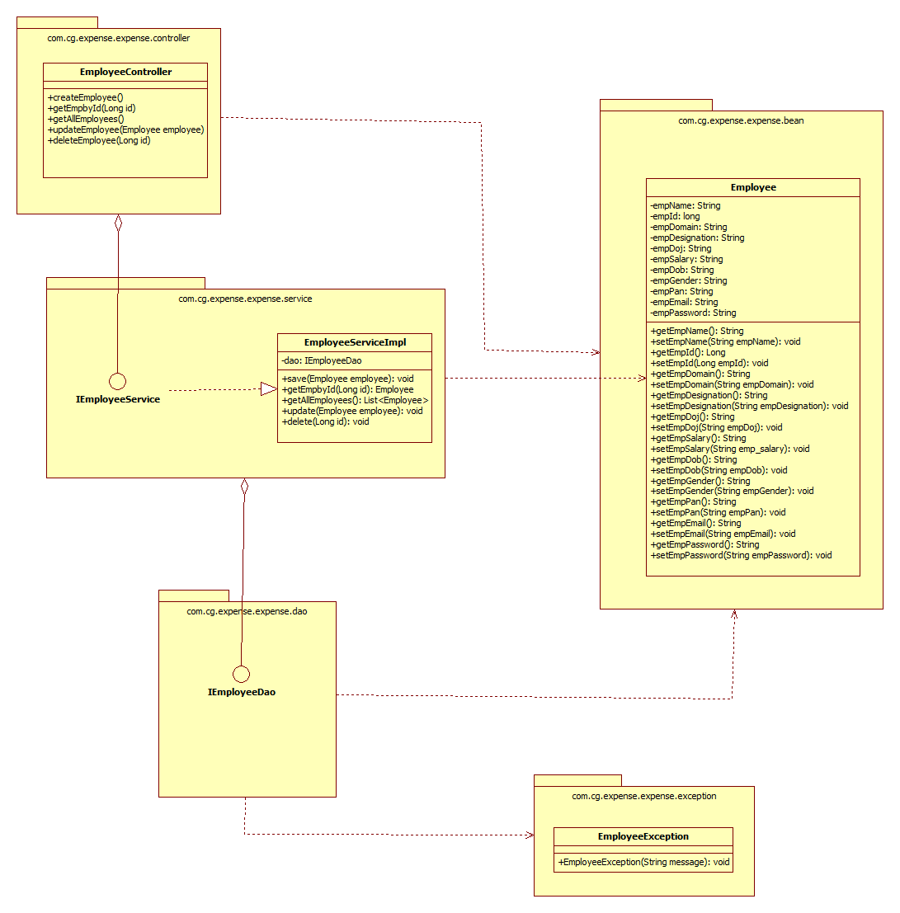

# Sequence Diagrams

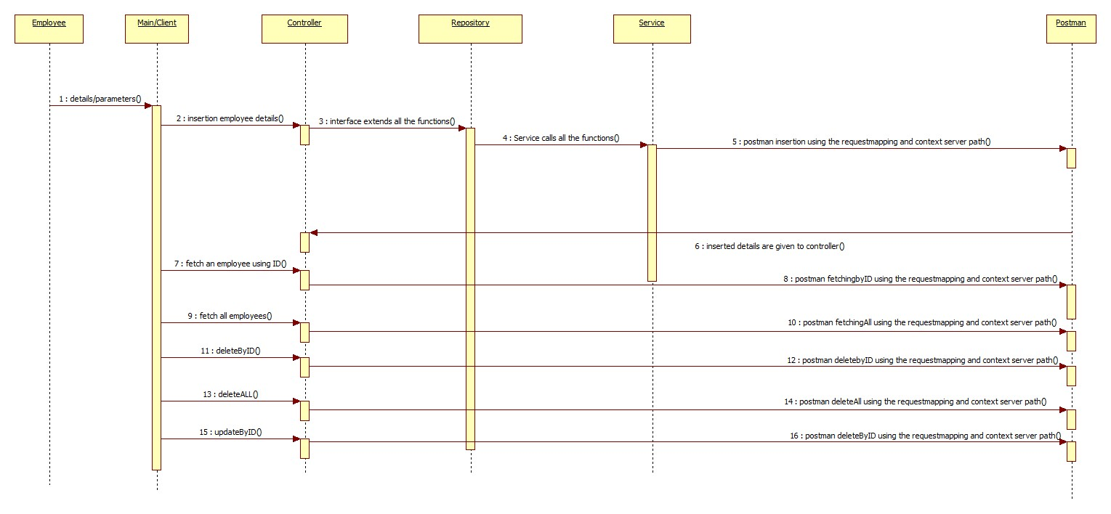

# Design Components

## List Of UI Components

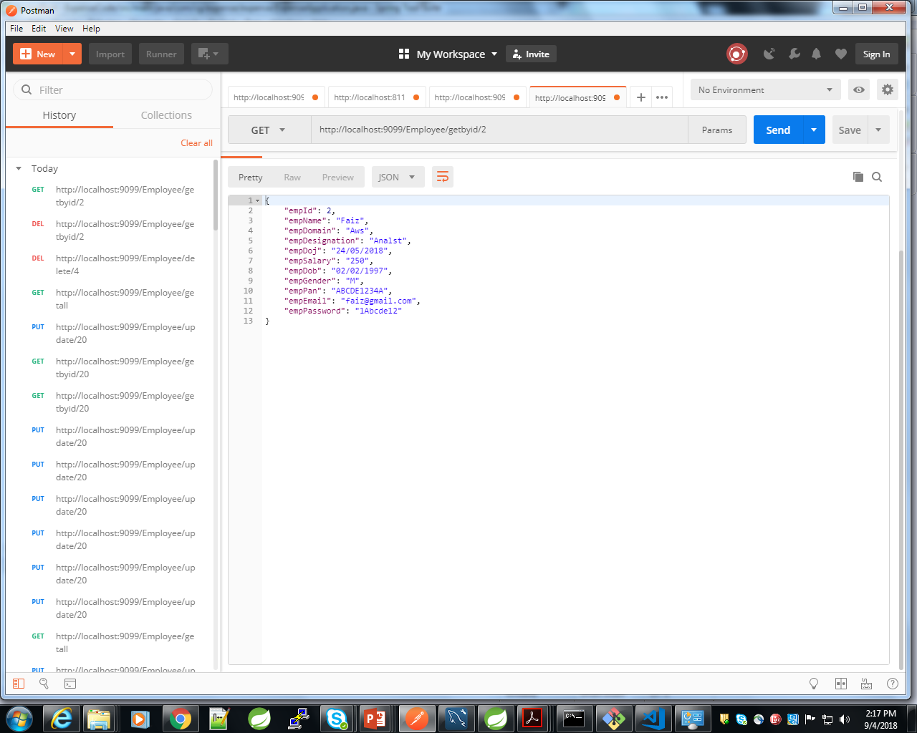

## List Of Design Classes

|  |  |  |  |  |
| --- | --- | --- | --- | --- |
| **Sr. No.** | **LLD Name** | **Class/Interface Name** | **Method Name** | **Method Description** |
| 1 | GetEmployeeByID Module | Employee | Appropriate getters and setters methods | Getters retrieve the property values and setters set the property values |
| 2 | GetEmployeeByID Module | EmployeeController | **public ExpApp getEmployeeById(@PathVariable Long emp_id)** | Sets the model attribute.  The controller function is called by the EmployeeServiceImpl and the repository IEmployeeDao acts as an interface.Using Postman, we can get the details of the employee using ID. |
| 3 | GetEmployeeByID Module | EmployeeServiceImpl | **public ExpApp getEmployeeById(Long emp_id)** | Calls the DAO layer method to get the employee details in to the database by ID. |
| 4 | GetEmployeeByID Module | IEmployeeDao | **public** **interface** IEmployeeDao **extends** JpaRepository<ExpApp, Long> | generates the employee information into the database using ID and returns the result to EmployeeServiceImpl  . |

# Re-Usable Routines/Components

Re-Usable Routines/Components

* JSP files
* Pom.xml files
* EmployeeException class
* Database-MySQL properties files
* Logger properties files
* Postman

# Messages

|  |  |  |
| --- | --- | --- |
| **#.** | **Type** | **Message Text** |
| M1 | Error | Name should be atleast Three Characters |
| M2 | Error | Employee Domain should Start with a capital letter followed by combination of lowercase and uppercase letters within range of 3 to 20 characters. |
| M3 | Error | Employee Designation should Start with a capital letter followed by combination of lowercase and uppercase letters within range of 3 to 30 characters. |
| M4 | Error | Salary should be in positive numbers |
| M5 | Error | Gender should be valid Either (M,F,O) or (Male or Female or Other) |
| M6 | Error | PAN number should be in format ABCDE1234A |
| M7 | Error | EMAIL should be in format of [abc@capgemini.com] |
| M8 | Error | Must contain at least one number and one uppercase and lowercase letter, and at least 8 or more characters |
| M9 | Error | Validation Failed |

# Configuration Files

|  |  |  |
| --- | --- | --- |
| File Name | Path | Description |
| application.properties | /ExpenseEmployee/src/main/resources/application.properties | To configure database connection. |
| pom.xml | /ExpenseEmployee/pom.xml | To configure the bean properties. |
| Postman | localhost:9098/Employee/employees/{id} | To configure the request mapping and view resolver. |

# Crud Matrix Table

|  |  |  |  |  |  |
| --- | --- | --- | --- | --- | --- |
| **#** | **Table Name** | **Create** | **Read** | **Update** | **Delete** |
| 1. | Employee | N | Y | N | N |

# Data Mapping Matrix

|  |  |  |  |  |  |  |  |
| --- | --- | --- | --- | --- | --- | --- | --- |
| **Sr. No.** | **Screen Label** | **Field Source** | **Field Type** | **Data Type** | **Max Length** | **Data Flow** | **Mandatory** |
| 1 | Employee ID | Employee.emp_id | Label | Number | NA | UI🡪D | Yes |
| 2 | EmployeeName | Employee.emp_name | Label | Varchar2 | 100 | UI🡪D | Yes |
| 3 | EmployeeDesignation | Employee.emp_designation | Label | Varchar2 | 100 | UI🡪D | Yes |
| 4 | EmployeeDomain | Employee.emp_domain | Label | Varchar2 | 100 | UI🡪D | Yes |
| 5 | EmployeeDOJ | Employee.emp_doj | Label | Date | NA | UI🡪D | Yes |
| 6 | Employee Salary | Employee.emp_salary | Label | Number | NA | UI🡪D | Yes |
| 7 | EmployeeDOB | Employee.emp_dob | Label | Date | NA | UI🡪D | Yes |
| 8 | EmployeeGender | Employee.emp_gender | Label | Varchar2 | 100 | UI🡪D | Yes |
| 9 | EmployeePAN | Employee.emp_pan | Label | Varchar2 | 100 | UI🡪D | Yes |
| 10 | EmployeeMailID | Employee.emp_mailid | Label | Varchar2 | 100 | UI🡪D | Yes |
| 11 | EmployeePassword | Employee.emp_password | Label | Varchar2 | 100 | UI🡪D | Yes |
| 13 | GET | Postman | Button | NA | NA | PM🡪UI | Yes |
| 14 | Cancel | Postman | Button | NA | NA | PM🡪UI | Yes |

**Legend**

D 🡪 UI (Database to User Interface)

UI 🡪 D (User Interface to Database)

UI (User Interface Only)

PM🡪UI (Postman to User Interface)

# Action Flow Matrix

|  |  |  |  |
| --- | --- | --- | --- |
| **Sr. No.** | **Action** | **Description** | **Process** |
| 1 | On Running the code in the console. | Spring Application starts. | The admin clicks on the Run button in the Spring and console generates with the success message.Then open the Postman. |
| 2 | On changing the action panel to GET and generating the details. | The employee details are generated into the database. | Data is shown in the fields based on the ID mentioned in the database using Postman. |

# Stored Procedures

|  |  |  |  |  |
| --- | --- | --- | --- | --- |
| **#** | **Stored Procedure Name**  **(with Description)** | **Input/Out Parameters** | **Type** | **Size** |
| 1. | NA | NA | NA | NA |

# Program Specification / Pseudo Code

## <ACTION :GETByID_Employee >

**Pseudo Code:**

1. **Client Side Scripting:**

None

1. **Server Side Scripting:**

**BEGIN**

**Controller:**

@GetMapping("/employees/{emp_id}")

**public** Employee getEmployeeById(@PathVariable Long emp_id) {

**return** service.getEmployeeById(emp_id);

}

**Service:**

**public** Employee getEmployeeById(Long emp_id) **throws** EmployeeException{

**return** dao.findById(emp_id).get();

}

**END**

**14. 2 <ACTION: GETByID Employee_CLICK>**

**Pseudo Code:**

1. **Client Side Scripting:**

IF invalid EmployeeName

Print Error Message M1

IF invalid EmployeeDomain

Print Error Message M2

IF invalid EmployeeDesignation

Print Error Message M3

IF invalid EmployeeSalary

Print Error Message M4

IF invalid EmployeeGender

Print Error Message M5

IF invalid EmployeePAN

Print Error Message M6

IF invalid EmployeeEmail

Print Error Message M7

IF invalid EmployeePassword

Print Error Message M8

IF invalid Validations

Print Error Message M9

1. **Server Side Scripting:**

**BEGIN**

Call getEmployeeById(@PathVariable Long emp_id) from controller to service

**BEGIN**

Call getEmployeeById(Long emp_id) **throws** EmployeeException to Repository interface from Service Layer

**BEGIN**

Fetching the details of the employee by ID is done through Postman.

**END**

Return Details. to Service Layer.

**END**

Return Details to Controller Layer.

**END**

IF error during GetbyID process occurs, then show error message.

**14. 2 <ACTION: CANCEL_CLICK>**

**Pseudo Code:**

**1. Client Side Scripting:**

None

**2. Server Side Scripting:**

**BEGIN**

Call getEmployeeById(@PathVariable Long emp_id) from controller to service

Fetching the details of the employee by ID is done through Postman.

**END**

REVISION HISTORY OF THE WORK PRODUCT

|  |  |  |  |  |  |
| --- | --- | --- | --- | --- | --- |
| # | Date | Version # | Section Changed | Details of changes made | Approved By |
| 1 | 29/08/2018 | 1.0 | LLD prepared | N/A |  |
| 2 | 29/08/2018 | 1.1 | Reusable components,  Pseudo code | Reusable components added.  The pseudo code is modified as per the specified flow. |  |
| 3 | 29/08/2018 | 1.2 | Reusable components,  References,  Data Mapping Matrix. | Reusable Components added.  File name with relative path is added in the references section.  The name of text boxes(screen label is changed). |  |
| 4 | 29/08/2018 | 1.3 | Configuration files,UI Components | Paths of the configuration files is updated and UI components(Screen Shots) added. |  |